**PRODUCT ANALYSIS**

**Which Product is Sold and When (Seasonal Analysis)**

**Graph-1**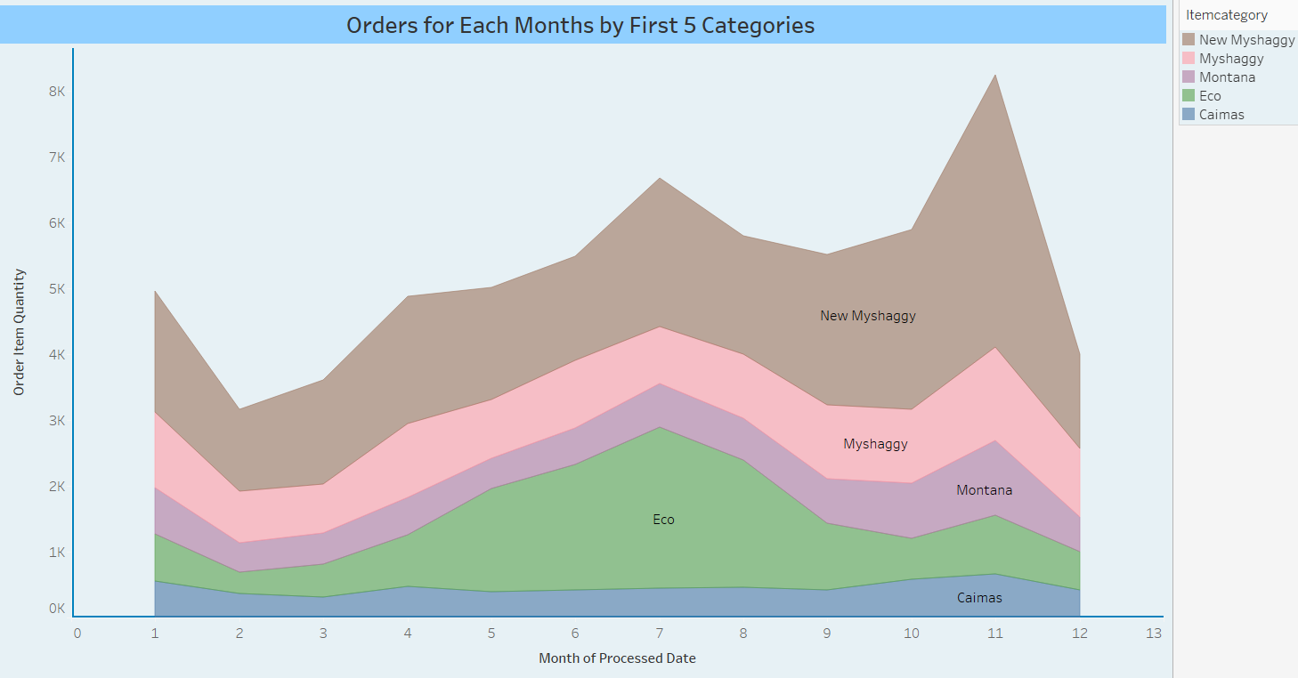

In this analysis, five best-selling products were examined. When the 5 best selling seasonal products are examined, it is seen that the sales trend of the product “Caimas” increased in September, peaked in November and started to decline in December.

When we look at the "New Myshaggy" in the first row, it is observed that there is a decrease from January to February, but there is a rise from February to July, there is a decrease in July-August, but a sharp upward trend is observed again from September. It is understood that this situation is the same for the products in the 2nd, 3rd and 4th rows.

**Graph-2**

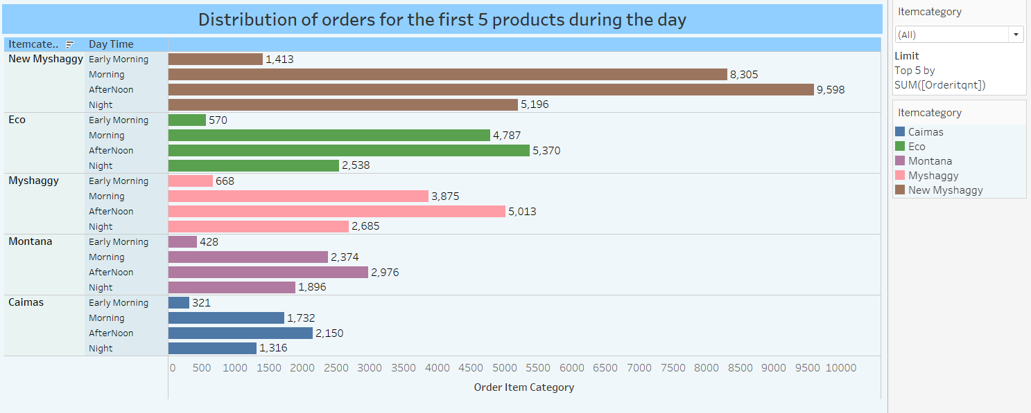

When the products in the first 5 categories are examined in which time period during the day; it is seen that the most sales are made in the afternoon, in the morning, in the evening and in the early morning, according to the order.

**2. Which Product is Sold on Which Platform and How Many?**

**Graph-1**

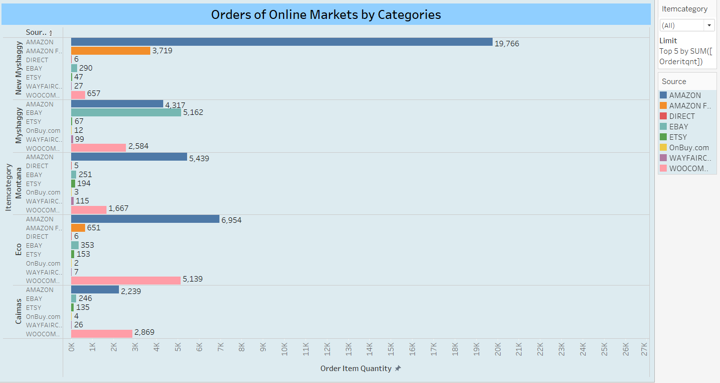

When the 5 best-selling products in the product category are examined, it is seen that the best-selling “New Myshaggy” is sold on Amazon, “Mysaggy” in the 2nd place is sold on EBAY, Montana in the 3rd place and Eco in the 4th place, in the 5th place and in the Amazon. It is seen that the “Caimas” type is sold at Woocommerce.

According to these results, the following can be said, the sales of each product on online platforms may differ.

**3. Analysis of Returned Products and Reasons for Returns**

**Graph-1**

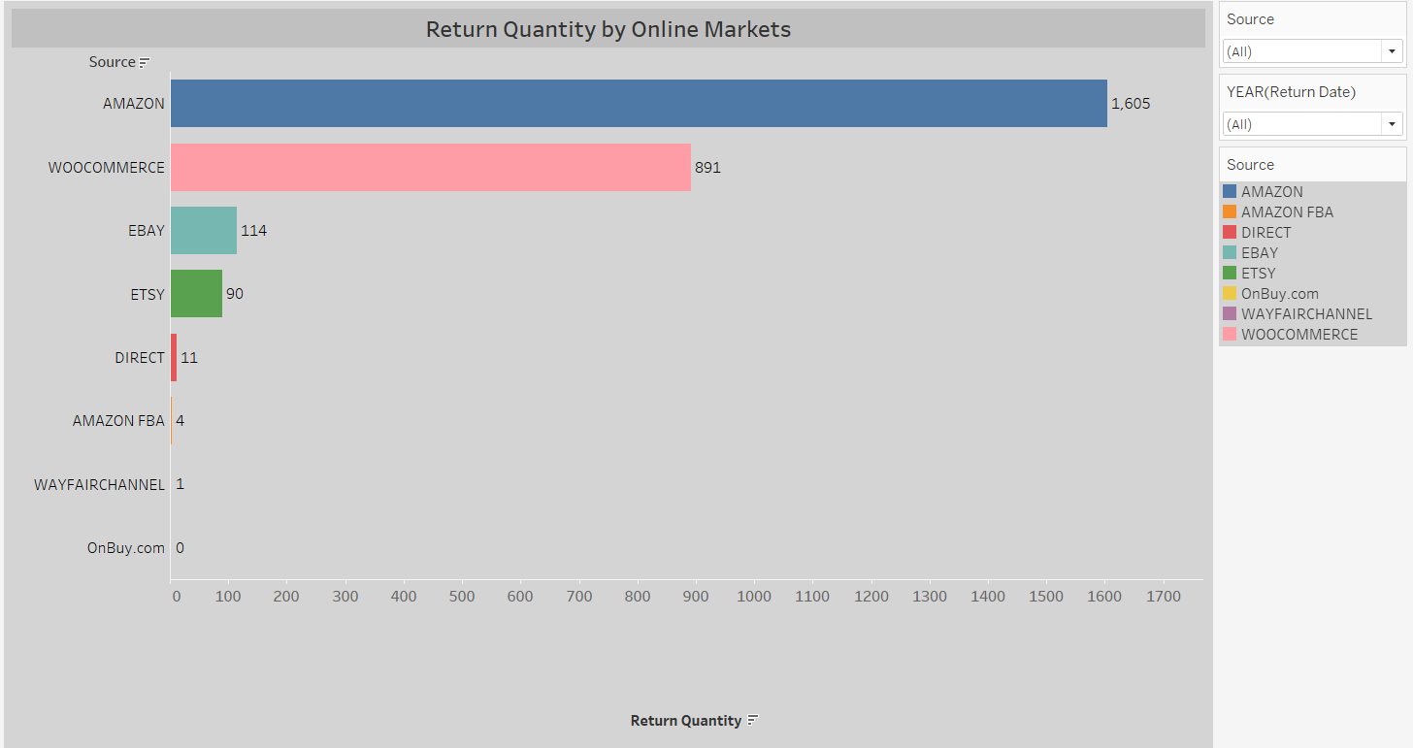

It is seen that the most returned products are from Amazon and then from Woocommerce. It is understood that this result is directly proportional to the orders received from online platforms.

**Graph-2**

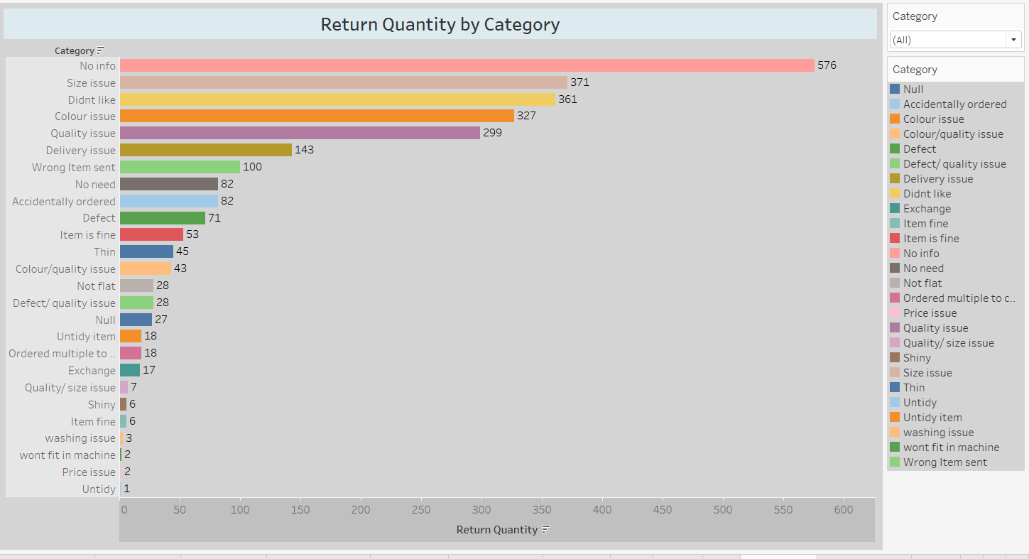

Considering the number and justifications of the returned products, the customer returned the first 576 products without giving any reason. 2. The customer returned 361 items in the order due to the size of the product. 3. If the next 327 items are returned, the product was made because the product was not liked. Returns in the 4th, 5th and 6th rows were made due to quality, color and distribution problems.

Regarding these results, water can be said; The customer can return the product for different reasons. Therefore, the seller should review the accuracy of the product information and the ability of the images to reflect the product in order to ensure customer satisfaction. Every stage of online sales should be done with care and customer relations should be well managed.

**Graph-3**

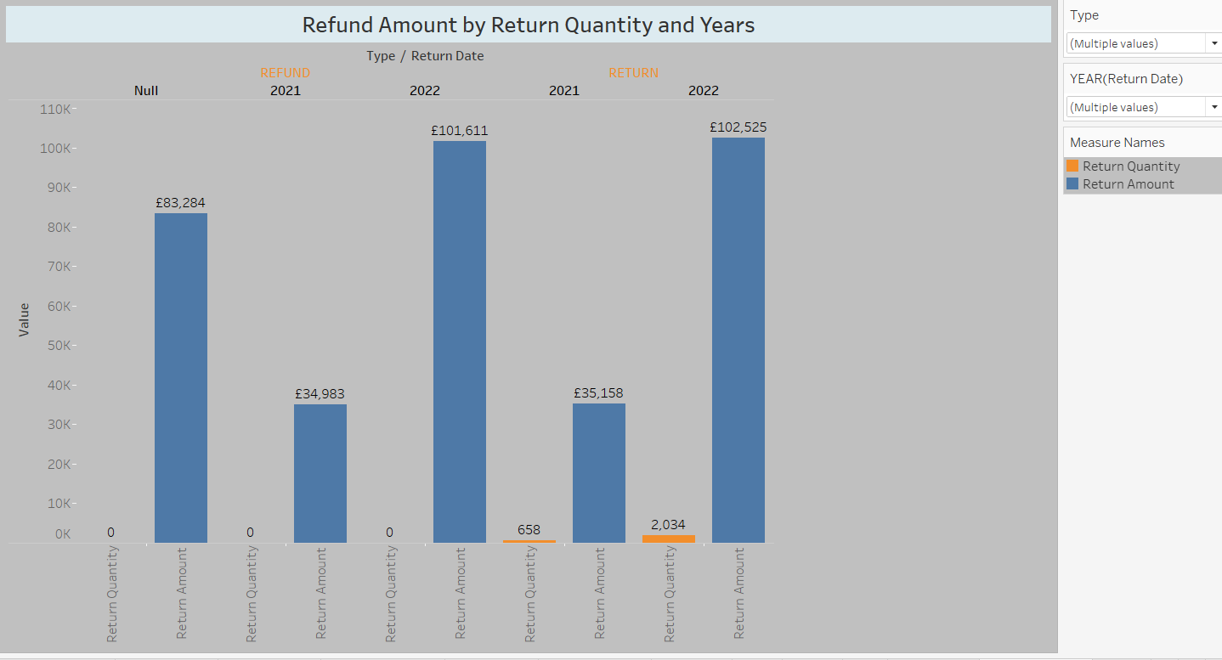

When the types of returned products are examined by years, it is seen that the refund amount in the years 2021 and 2022 is 101611 £ and the year 2022 at the most, in an unspecified year.

When the return status of return type products is examined, it is seen that 658 products were returned in 2021 and 2034 products in 2022. It is understood that these returns are directly proportional to the year in which the turnover is made.

Note: In Dataset, if the type of returned products is non-refundable, the return quantity is zero(0).

**Graph-4**

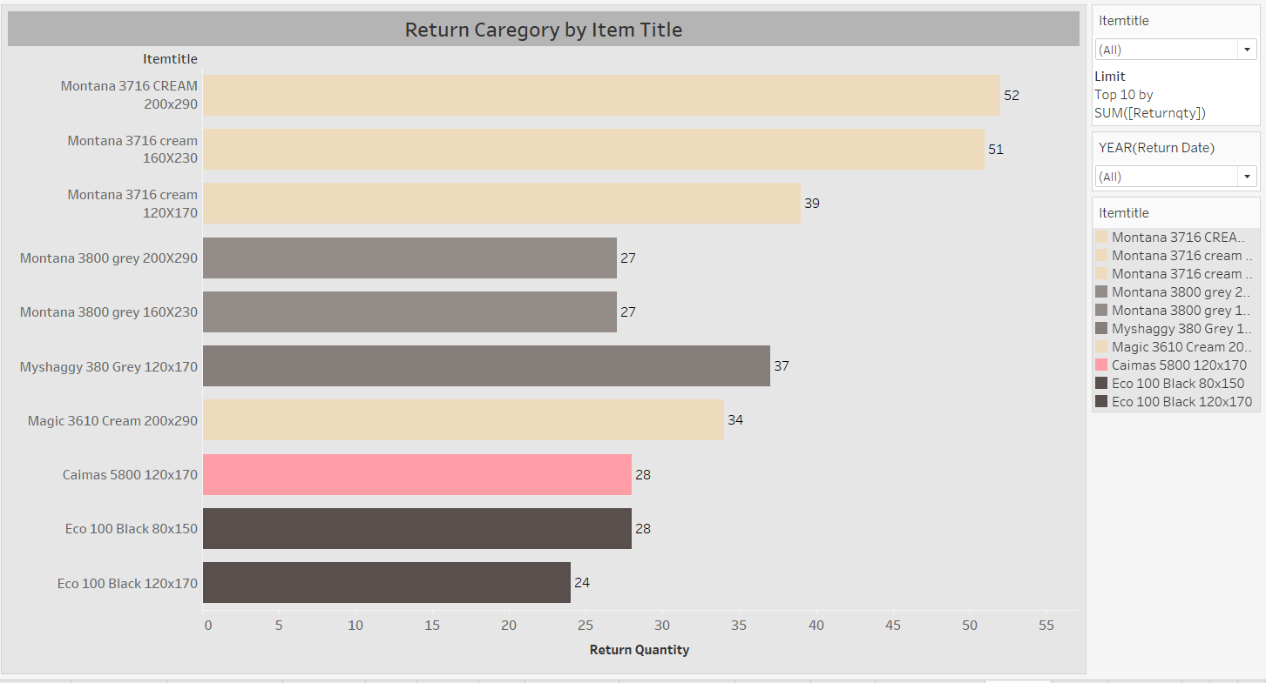

When the 10 most returned product categories are examined, it is seen that the large sizes (120x170, 160x230 and 200x290) of the Montana3716 cream and Montana 3800 gray categories are returned.

When the other returned categories are examined, it is seen that cream, gray and black colors are returned.

It is considered that it would be beneficial for the company to review the sales of these color products.

**Graph-5**

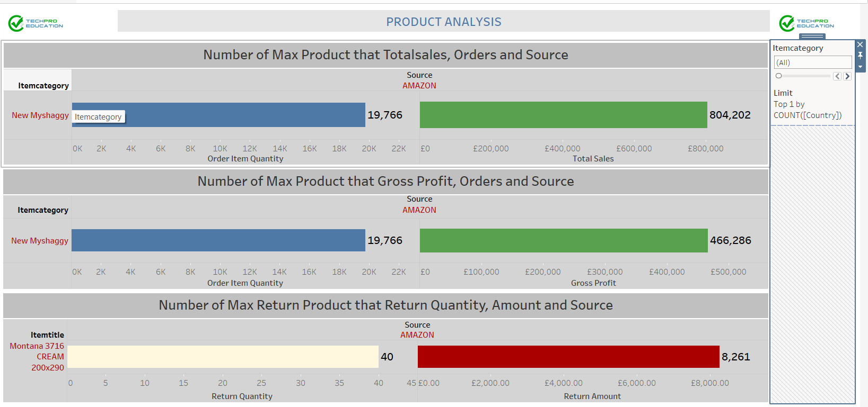

It is seen that 19766 units were sold from the amazon platform in the “New Myshaggy” tour, with a total turnover of 466286 pounds.

It is seen that the highest gross profit was obtained from the “New Myshaggy” category sold on amazon and £466286.

It is understood that the most returns from the products are made in the size of “Montana 3716 cream 200x290” and the cost of this is £ 8261.